**Department of**

**COMPUTER SCIENCE AND ENGINEERING**

|  |  |
| --- | --- |
| Class | IV B.TECH. I SEM |
| Branch | CSE |
| Regulation | R15 |
| Name of the Lab | MOBILE APPLICATION DEVELOPMENT |
| Academic year | 2018-19 |

**MOBLE APPLICATION DEVELOPMENT LABSYLLABUS:**

**(15A05711)**

***Course Objective:***

* *To understand fundamentals of android operating systems.*
* *Illustrate the various components, layouts and views in creating androidApplications*
* *To understand fundamentals of android programming.*

***Learning Outcome:***

*After completion of the course the students will be able*

* *Create data sharing with different applications and sending and intercepting SMS.*
* *Develop applications using services and publishing android applications.*
* *To demonstrate their skills of using Android software development tools*

**List of Experiments: (All the Experiments are to be conducted)**

1. Setting Up the Development Environment
2. Create "Hello World" Application

2.1 Create a new Android Project

2.2 Run "Hello World" on the Emulator

2.3 On a Physical Device

2.4 Greeting the User

1. Create Application by Using Widgets

3.1 Creating the Application by using the Activity class

(i) onCreate()

(ii) onStart()

(iii) onResume()

(iv) onPause()

(v) onStop()

(vi) onDestroy()

(vii) onRestart()

3.2 Creating the Application by using Text Edit control.

3.3 Creating the Application Choosing Options

(i) CheckBox

(ii) RadioButton

(iii) RadioGroup

(iv) Spinner

1. Create Application by Using Building Blocks for Android Application Design

4.1 Design the Application by using

(i) Linear Layout

(ii) Relative Layout

(iii) Absolute Layout

4.2 Create the Application to play the Audio and Video clips.

1. Create Application by Using Building Menus and Storing Data

5.1 Design the Application for Menus and Action Bar

5.2 Design the application to display the Drop-Down List Action Bar

|  |  |  |
| --- | --- | --- |
| **S.No.** | **Name of the experiment** | **Page No.** |
| 1 | Setting Up the Development Environment | **04** |
| 2 | Create "Hello World" Application  2.1 Create a new Android Project  2.2 Run "Hello World" on the Emulator  2.3 On a Physical Device  2.4 Greeting the User | **12** |
| 3 | Create Application by Using Widgets  3.1 Creating the Application by using the Activity class  (i) onCreate()  (ii) onStart()  (iii) onResume()  (iv) onPause()  (v) onStop()  (vi) onDestroy()  (vii) onRestart() | **13** |
| 3.2 Creating the Application by using Text Edit control. | **15** |
| 3.3 Creating the Application Choosing Options  (i) CheckBox | **16** |
| (ii) RadioButton | **20** |
| (iii) RadioGroup | **22** |
| (iv) Spinner | **24** |
| 4 | Create Application by Using Building Blocks for Android Application Design  4.1 Design the Application by using  (i) Linear Layout | **26** |
| (ii) Relative Layout | **28** |
| (iii) Absolute Layout | **31** |
| 4.2 Create the Application to play the Audio and Video clips. | **33** |
| 5 | Create Application by Using Building Menus and Storing Data  5.1 Design the Application for Menus and Action Bar | **37** |
| 5.2 Design the application to display the Drop-Down List  Action Bar | **40** |

***Signature of the Staff member***:

|  |  |
| --- | --- |
| Exp.No. 1 | **SETTING UP THE DEVELOPMENT ENVIRONMENT** |
| Dt. |

**AIM:** Setting Up the Development Environment

**PROCEDURE:**

This Java Development Kit(JDK) allows you to code and run Java programs. It's possible that you install multiple JDK versions on the same PC. But Its recommended that you install only latest version.

Following are steps to install Java in Windows

**Step 1)** Go to [link](http://www.oracle.com/technetwork/java/javase/downloads/index.html). Click on Download JDK. For java latest version.

[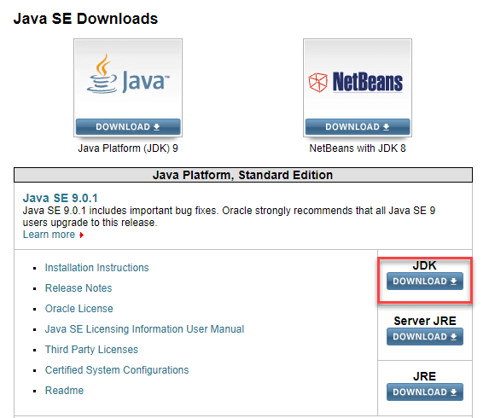](https://cdn.guru99.com/images/java/111417_1107_Java21.png)

**Step 2)** Next,

1. Accept License Agreement
2. Download latest Java JDK for your version(32 or 64 bit) of java for Windows.

[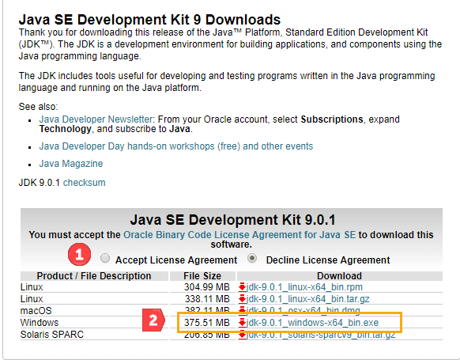](https://cdn.guru99.com/images/java/111417_1107_Java22.png)

**Step 3)** Once the download is complete, run the exe for install JDK. Click Next

[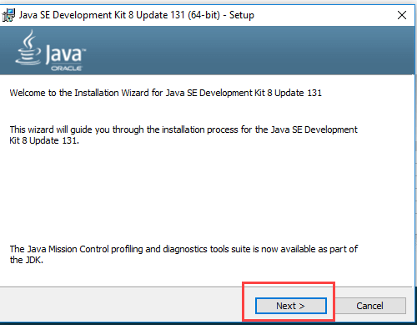](https://cdn.guru99.com/images/java/111417_1107_Java23.png)

**Step 4)** Once installation is complete click Close

[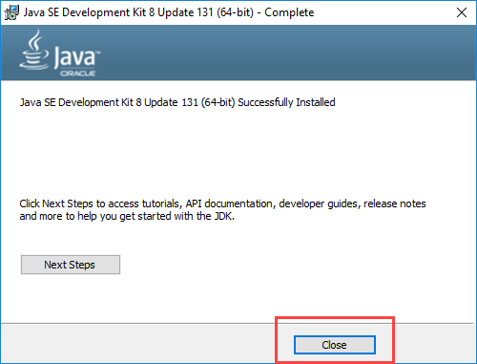](https://cdn.guru99.com/images/java/111417_1107_Java24.png)

**How to set Environment Variables in Java: Path and Classpath**

The PATH variable gives the location of executables like javac, java etc. It is possible to run a program without specifying the PATH but you will need to give full path of executable like ***C:\Program Files\Java\jdk1.8.0_131\bin\javac A.java*** instead of simple ***javac A.java***

The CLASSPATH variable gives location of the Library Files.

Let's look into the steps to set the PATH and CLASSPATH

**Step 1)** Right Click on the My Computer and Select the properties

**Step 2)** Click on advanced system settings

**Step 3)** Click on Environment Variables

[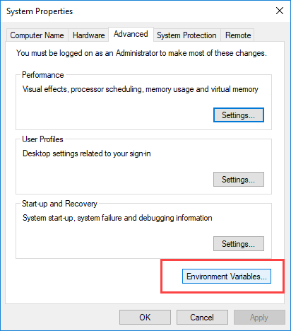](https://cdn.guru99.com/images/java/111417_1107_Java27.png)

**Step 4**) Paste Path of bin folder in Variable value and click on OK Button.

[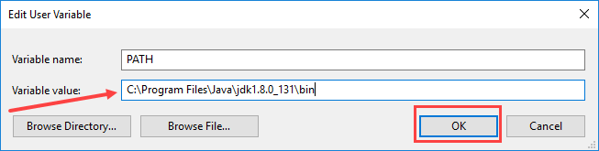](https://cdn.guru99.com/images/java/111417_1107_Java211.png)

**Step 5)** Click on OK button

[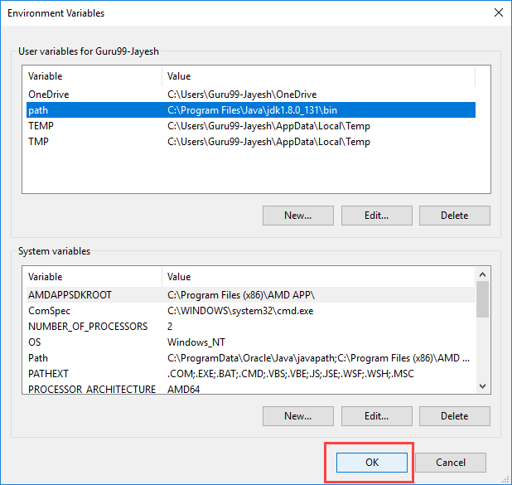](https://cdn.guru99.com/images/java/111417_1107_Java213.png)

**Step 1: Obtain the Android SDK**

**[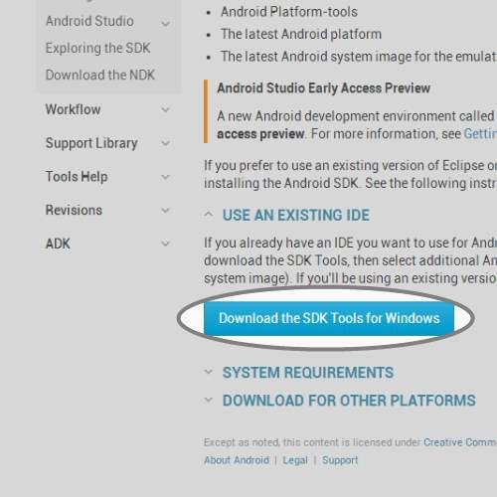](https://cdn.instructables.com/FZ0/9D35/HSGFXUMG/FZ09D35HSGFXUMG.LARGE.jpg)**

* We need to obtain the Android Software Development Kit. To do that we must first visit the SDK download site below.
* <http://developer.android.com/sdk/index.html>
* Scroll to the bottom of the webpage and select the 'Download the SDK Tools' button.
* This will open a file to be saved somewhere.

**Step 2: Install the Android SDK**

[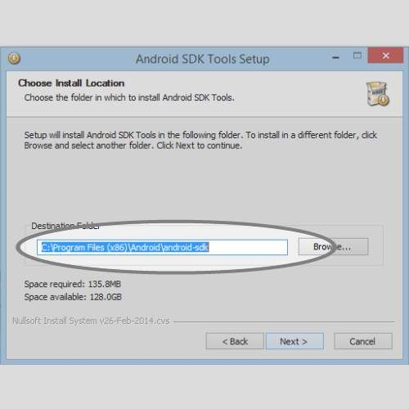](https://cdn.instructables.com/FFM/Z698/HSGFXX2A/FFMZ698HSGFXX2A.LARGE.jpg)

* Open the file we just downloaded.
* This will open an executable which will ask you about the installation process.
* When you get to the install location screen, make sure you choose a location you remember (we will need it later).

**Step 3: Open Android SDK Manager**

[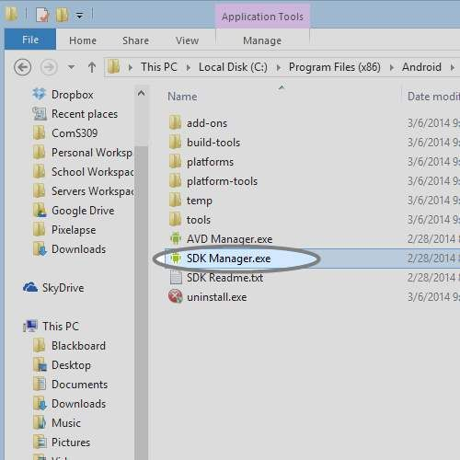](https://cdn.instructables.com/FOF/JE1U/HSHDS5JL/FOFJE1UHSHDS5JL.LARGE.jpg)

We'll select the most recent version along with the extra SDK tools so you can build applications for any Android version.

* Open the folder that we installed the SDK into.
* You'll see a executable called 'SDK Manager'. Open it.
* You'll see a window where you can select different versions of Android to develop for.

**Step 4: Install Android Version and Extras for SDK**

[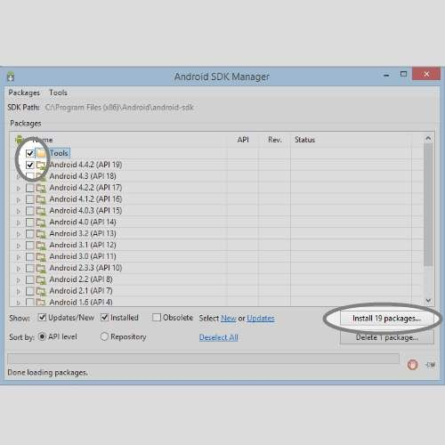](https://cdn.instructables.com/FOH/ABIZ/HSGFXZH4/FOHABIZHSGFXZH4.LARGE.jpg)

* Select the 'Tools' and 'Android 4.4.2 (API 19)' check boxes.
* If you would like to have extra Android tools you can choose them from the 'Extras' selection.
* You will then be prompted to accept the Android conditions and then the SDK will install. Then installation may take a while depending on your internet connection. The Android SDK is now completely installed.

**Step 5: Obtain Eclipse IDE**

[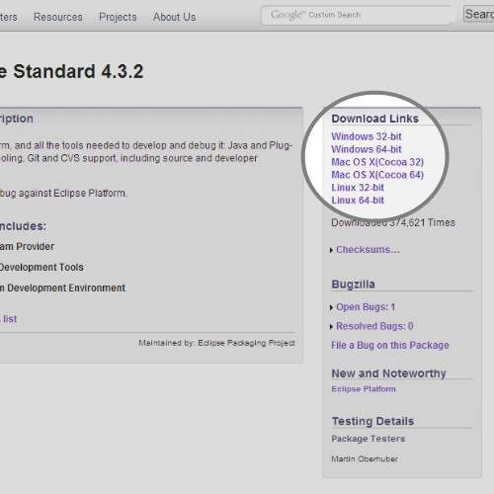](https://cdn.instructables.com/FJ9/8398/HSGFYBUC/FJ98398HSGFYBUC.LARGE.jpg)

Eclipse is the tool we'll be using to develop in. It is the most popular Android development environment and has officially supported tools from Google.

* Download Eclipse from the website below.
* [http://www.eclipse.org/downloads/packages/eclipse-...](http://www.eclipse.org/downloads/packages/eclipse-standard-432/keplersr2)
* Find the link for your operating system and 32/64 bit version.
* Save the compressed download file.

**Step 6: Run Eclipse for First Time**

[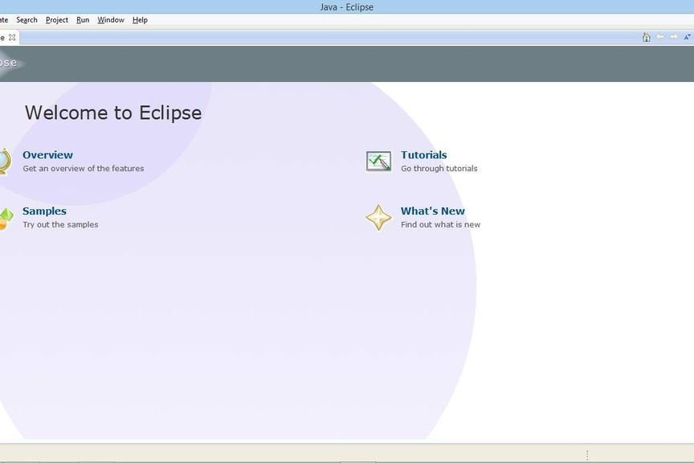](https://cdn.instructables.com/FZM/J8P1/HSGFYLXV/FZMJ8P1HSGFYLXV.LARGE.jpg)

Eclipse does not require installation. It's a folder with all the necessary files and settings. You can run it directly from the Eclipse folder. It's recommended you put it in a safe place with other applications.

* Extract the downloaded Eclipse file into a safe place where you can keep the program.
* Open the extracted folder and open the 'eclipse' executable.

**Step 7: Add ADT Plugin Repository**

[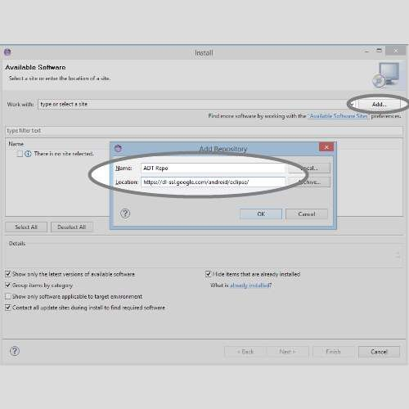](https://cdn.instructables.com/F11/VNPI/HSHDS5SM/F11VNPIHSHDS5SM.LARGE.jpg)

The ADT (Android Development Tool) Plugin was made specifically for Eclipse to increase productivity and integration with your Android work environment. To use it, we first add the Eclipse plugin repository so it knows where to find it along with updates.

* In the Eclipse application menu, go to 'Help' and then 'Install New Software'.
* Click on the 'Add...' button and you'll see a window appear.
* Give the repository a name like 'ADT Repo'.
* Give it the location [http://dl-ssl.google.com/android/eclipse/.](http://dl-ssl.google.com/android/eclipse/)
* Click 'OK' button.

**Step 8: Install ADT Plugin**

[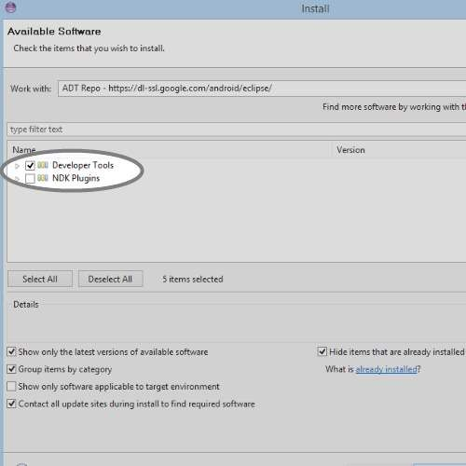](https://cdn.instructables.com/FCH/UUIF/HSHDS5XF/FCHUUIFHSHDS5XF.LARGE.jpg)

Now that we have the plugin repo setup we need to install the plugin from it.

* On the 'Install Software' screen, select the repo you just created from the 'Work with' selector.
* Select the 'Developer Tools' option from the listed below options.
* Click 'Next' and accept the agreements.
* Click 'Finish' and let it install. It might take a while depending on your internet speed.

**Step 9: Access ADT Plugin Preferences**

[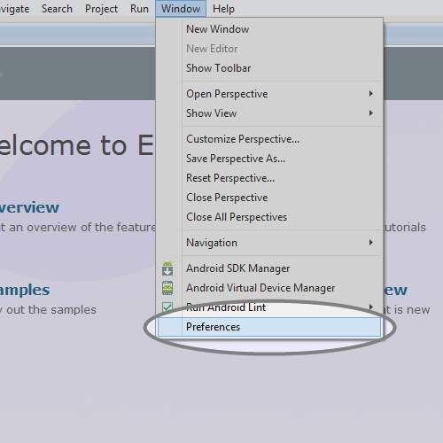](https://cdn.instructables.com/FFW/4GU4/HSHDS67B/FFW4GU4HSHDS67B.LARGE.jpg)

You'll most likely have to restart Eclipse after you install the ADT Plugin so do that before you continue.

* Mac/Linux: After Eclipse has restarted, click 'Eclipse' in the application menu.
* Windows: After Eclipse has restarted, click 'Window' in the application menu.
* Then select 'Preferences'.
* In the Preferences window, select the Android tab on the left side and it's corresponding drop down menu.

This is the ADT Preferences screen. It will allow you to change setting, remove the SDK and make editor preferences for your development.

**Step 10: Setup ADT Plugin**

[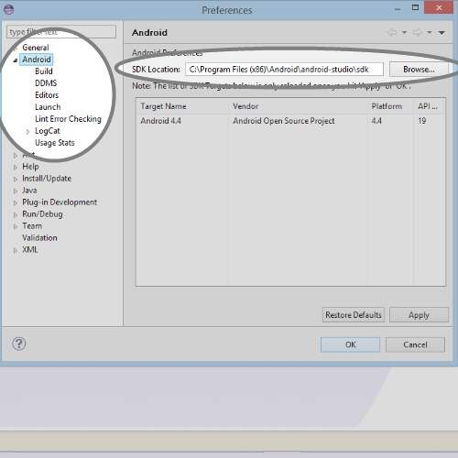](https://cdn.instructables.com/FC8/669R/HSHDS6LI/FC8669RHSHDS6LI.LARGE.jpg)

* Click 'Browse' on the right side of the screen.
* Search for the folder in which you installed the Android SDK into and select it.
* Hit the 'Apply' button on the Preferences screen.
* You should see the Android version you installed early to show up if all went well.
* If not, try reselecting the folder. (Make sure the folder contains the folders 'build-tools','platform','extras' and etc.
* Hit the 'OK' button and restart Eclipse.

**Step 11: Access ADT Android Virtual Device Manager**

[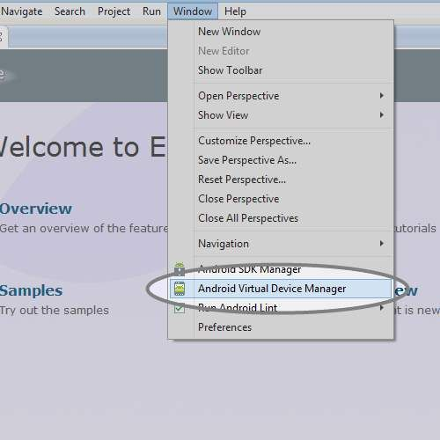](https://cdn.instructables.com/FWO/LZB0/HSHDS6S7/FWOLZB0HSHDS6S7.LARGE.jpg)

To test your application we need to add an Android Virtual Device if you don't have a personal device.

In the application menu, select 'Window' and then 'Android Virtual Device Manager'

Here you can create new 'Devices'.

|  |  |
| --- | --- |
| Exp.No. 2 | **CREATE "HELLO WORLD" APPLICATION** |
| Dt. |

**AIM:** Create "Hello World" Application

**PROCEDURE:**

Step 1: Create a new project and name it Helloworld

In this step we create a new project in android studio by filling all the necessary details of

the app like app name, package name, api versions etc.

Select File -> New -> New Project and Fill the forms and click “Finish” button.

Step 2: Now Open res -> layout -> activity_main.[xml](https://abhiandroid.com/ui/xml) (or) main.[xml](https://abhiandroid.com/ui/xml) and add the following

code:

2. Create "Hello World" Application

activity_main.[xml](https://abhiandroid.com/ui/xml)

*<?*xml version="1.0" encoding="utf-8"*?>*<android.support.constraint.ConstraintLayout

xmlns:android="http://schemas.android.com/apk/res/android"  
 xmlns:app="http://schemas.android.com/apk/res-auto"  
 xmlns:tools="http://schemas.android.com/tools"  
 android:layout_width="match_parent"  
 android:layout_height="match_parent"  
 tools:context="com.example.lenovo.helloworld.MainActivity">  
 <TextView  
 android:layout_width="wrap_content"  
 android:layout_height="wrap_content"  
 android:text="Hello World!"  
 app:layout_constraintBottom_toBottomOf="parent"  
 app:layout_constraintLeft_toLeftOf="parent"  
 app:layout_constraintRight_toRightOf="parent"  
 app:layout_constraintTop_toTopOf="parent" />  
</android.support.constraint.ConstraintLayout>

**MainActivity.java**

package com.example.lenovo.helloworld;  
import android.support.v7.app.AppCompatActivity;  
import android.os.Bundle;  
  
public class MainActivity extends AppCompatActivity {  
 @Override  
 protected void onCreate(Bundle savedInstanceState) {  
 super.onCreate(savedInstanceState);  
 setContentView(R.layout.*activity_main*);  
 }  
}

**OUT PUT**

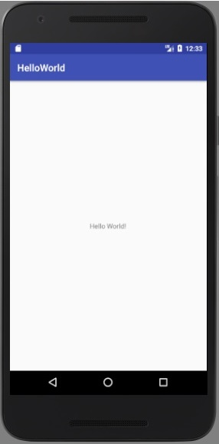

|  |  |
| --- | --- |
| Exp.No. 3.1 | **CREATE APPLICATION BY USING WIDGETS** |
| Dt. |

**AIM:** Creating the Application by using the Activity class

**PROCEDURE:**

**Step 1:** Create a new project and name it Activityclass

In this step we create a new project in android studio by filling all the necessary details of the app like app name, package name, api versions etc.

Select File -> New -> New Project and Fill the forms and click “Finish” button.

**Step 2:** Now Open res -> layout -> **activity_main.**[**xml**](https://abhiandroid.com/ui/xml)**(or) main.**[**xml**](https://abhiandroid.com/ui/xml)and add the following code:

3. Creating the Application by using the Activity class.

**Activity_main.xml**

*<?*xml version="1.0" encoding="utf-8"*?>*<android.support.constraint.ConstraintLayout xmlns:android="http://schemas.android.com/apk/res/android"  
 xmlns:app="http://schemas.android.com/apk/res-auto"  
 xmlns:tools="http://schemas.android.com/tools"  
 android:layout_width="match_parent"  
 android:layout_height="match_parent"  
 tools:context="com.example.lenovo.prog2.MainActivity">  
  
 <TextView  
 android:layout_width="wrap_content"  
 android:layout_height="wrap_content"  
 android:text="Hello World!"  
 app:layout_constraintBottom_toBottomOf="parent"  
 app:layout_constraintLeft_toLeftOf="parent"  
 app:layout_constraintRight_toRightOf="parent"  
 app:layout_constraintTop_toTopOf="parent" />  
  
</android.support.constraint.ConstraintLayout>

**Step 3:** Now Open  app -> java-> package -> **MainActivity.java**

In this step we add the code to initiate the activity of application

MainActivity.java

package com.example.lenovo.prog2;  
import android.support.v7.app.AppCompatActivity;  
import android.os.Bundle;  
import android.widget.Toast;  
  
public class MainActivity extends AppCompatActivity {  
  
 @Override  
 protected void onCreate(Bundle savedInstanceState) {  
 super.onCreate(savedInstanceState);  
 setContentView(R.layout.*activity_main*);  
 }  
 @Override  
 protected void onStart() {  
 super.onStart();  
 Toast.*makeText*(this, "on start", Toast.*LENGTH_SHORT*).show();  
 }  
 @Override  
 protected void onPause() {  
 super.onPause();  
 Toast.*makeText*(this, "on pause", Toast.*LENGTH_SHORT*).show();  
 }

@Override  
 protected void onRestart() {  
 super.onRestart();  
 Toast.*makeText*(this, "on restart", Toast.*LENGTH_SHORT*).show();  
 }  
  
 @Override  
 protected void onResume() {  
 super.onResume();  
 Toast.*makeText*(this, "on resume", Toast.*LENGTH_SHORT*).show();  
 }  
  
 @Override  
 protected void onDestroy() {  
 super.onDestroy();  
 Toast.*makeText*(this, "on destroy", Toast.*LENGTH_SHORT*).show();  
 }  
}

**OUT PUT**

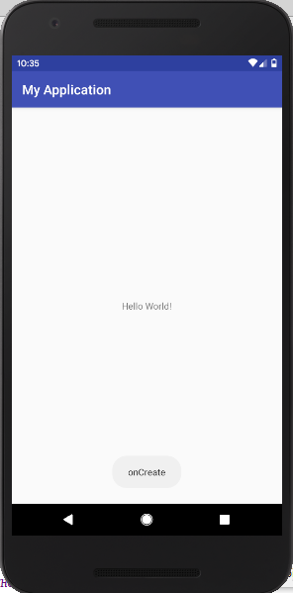 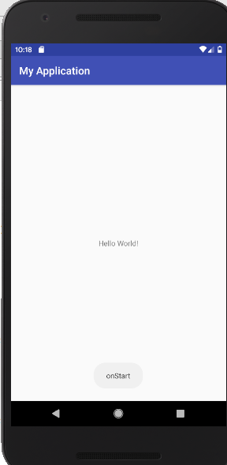 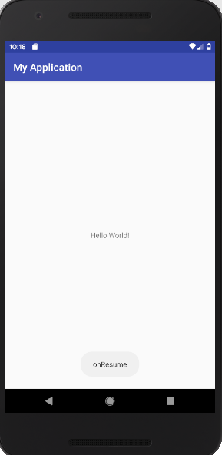

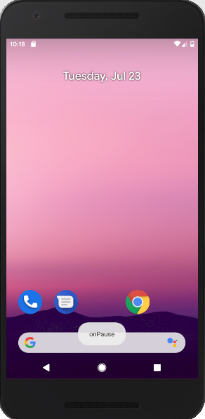 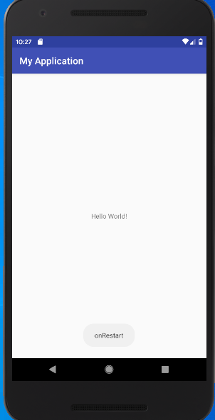 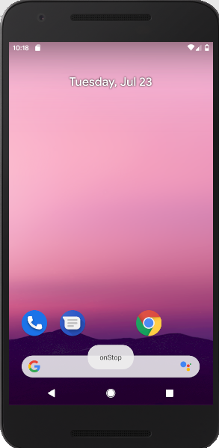

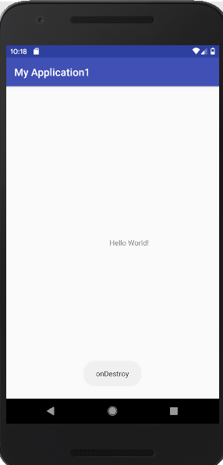

|  |  |
| --- | --- |
| Exp.No. 3.2 | **CREATE APPLICATION BY USING TEXTEDIT CONTROL** |
| Dt. |

**AIM:** Creating the Application by using Text Edit control

**PROCEDURE**:

Step 1: Create a new project and name it TexteditExample

In this step we create a new project in android studio by filling all the necessary details of the app like app name, package name, api versions etc.

Select File -> New -> New Project and Fill the forms and click “Finish” button.

Step 2: Now Open res -> layout -> activity_main.[xml](https://abhiandroid.com/ui/xml) (or) main.[xml](https://abhiandroid.com/ui/xml) and add the following code:

4. Creating the Application by using Text Edit control.

<LinearLayout xmlns:android="http://schemas.android.com/apk/res/android"  
 android:orientation="vertical"  
 android:layout_width="match_parent"  
 android:layout_height="match_parent">  
 <EditText  
 android:layout_width="match_parent"  
 android:layout_height="wrap_content"  
 android:id="@+id/user_name"

android:text="Enter your name:"/>  
 <TextView  
 android:layout_width="match_parent"  
 android:layout_height="wrap_content"  
 android:id="@+id/response"/>  
</LinearLayout>

**Step 3:** Now Open  app -> java-> package -> **MainActivity.java**

In this step we add the code to initiate the check boxes we created. And then we perform click event on button and display the text for selected check boxes using a toast

Package.com.androidunleashed.edittextapp;

import android.app.Activity;  
import android.os.Bundle;  
import android.widget.TextView;  
import android.widget.EditText;  
import android.view.View;  
import android.view.View.OnKeyListener;  
import android.view.KeyEvent;  
public class EditTextAppActivity extends Activity {  
 @Override  
 protected void onCreate(Bundle savedInstanceState) {  
 super.onCreate(savedInstanceState);  
 setContentView(R.layout.activity_edit_text_app);  
 final TextView resp= (TextView) this.findViewById (R.id.response);  
 final EditText username=(EditText) findViewById(R.id.user_name);  
 username.setOnKeyListener(new OnKeyListener() {  
 public boolean onKey(View v, int keyCode, KeyEvent event) {  
 if((event.getAction()== KeyEvent.ACTION_UP) &&

(keyCode==(KeyEvent.KEYCODE_ENTER))){  
 resp.setText("Welcome "+username.getText()+"!");  
 return true;  
 }  
 return false;  
 }  
 });  
 }  
}

**OUT PUT**

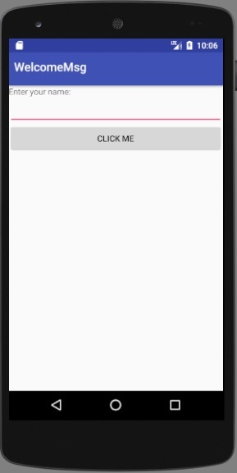 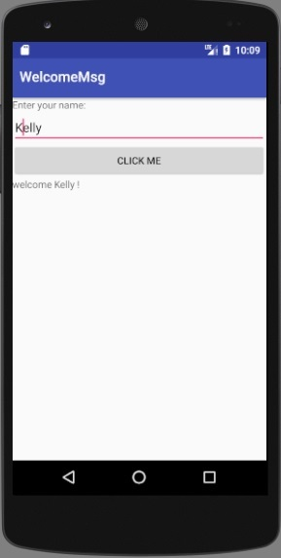

|  |  |
| --- | --- |
| Exp.No. 3.3(i) | **CREATE APPLICATION BY USING CHECK BOX CONTROL** |
| Dt. |

**AIM:** Creating the Application Choosing Options (Checkbox)

**PROCEDURE**:

Step 1: Create a new project and name it CheckBoxExample

In this step we create a new project in android studio by filling all the necessary details of the app like app name, package name, api versions etc.

Select File -> New -> New Project and Fill the forms and click “Finish” button.

Step 2: Now Open res -> layout -> activity_main.[xml](https://abhiandroid.com/ui/xml) (or) main.[xml](https://abhiandroid.com/ui/xml) and add the following code:

5. Creating the Application by using CheckBox control.

<LinearLayout xmlns:android="http://schemas.android.com/apk/res/android"  
 android:orientation="vertical"  
 android:layout_width="match_parent"  
 android:layout_height="match_parent">  
 <TextView  
 android:layout_width="match_parent"  
 android:layout_height="wrap_content"  
 android:text="Select Items you Want"/>  
 <CheckBox  
 android:id="@+id/checkbox_pizza"  
 android:layout_height="wrap_content"  
 android:text="pizza $15"  
 android:layout_width="match_parent"/>  
 <CheckBox  
 android:id="@+id/checkbox_hotdog"  
 android:layout_height="wrap_content"  
 android:text="Hot Dog $5"  
 android:layout_width="match_parent"/>  
 <CheckBox  
 android:id="@+id/checkbox_burger"  
 android:layout_height="wrap_content"  
 android:text="Burger $10"  
 android:layout_width="match_parent"/>  
 <Button  
 android:layout_width="match_parent"  
 android:layout_height="wrap_content"  
 android:id="@+id/bill_btn"  
 android:text="Calculate Bill"/>  
 <TextView  
 android:layout_width="match_parent"  
 android:layout_height="match_parent"  
 android:id="@+id/amount"/>  
</LinearLayout>

**Step 3:** Now Open  app -> java-> package -> **MainActivity.java**

In this step we add the code to initiate the check boxes we created. And then we perform click event on button and display the text for selected check boxes using a TextView

package com.androidunleashed.checkboxapp;

import android.app.Activity;  
import android.os.Bundle;  
import android.widget.Button;  
import android.widget.TextView;  
import android.widget.CheckBox;  
import android.view.View;  
import android.view.View.OnClickListener;  
public class CheckBoxAppActivity extends Activity implements OnClickListener{  
 CheckBox c1,c2,c3;  
 TextView resp;  
 @Override  
 protected void onCreate(Bundle savedInstanceState) {  
 super.onCreate(savedInstanceState);  
 setContentView(R.layout.activity_check_box_app);  
 Button b=(Button)this.findViewById(R.id.bill_btn);  
 resp=(TextView)this.findViewById(R.id.amount);  
 c1=(CheckBox)this.findViewById(R.id.checkbox_pizza);  
 c2=(CheckBox)this.findViewById(R.id.checkbox_hotdog);  
 c3=(CheckBox)this.findViewById(R.id.checkbox_burger);  
 b.setOnClickListener(this);  
 }  
 public void onClick(View v){  
 int amt=0;  
 if(c1.isChecked()){  
 amt=amt+15;

}  
 if(c2.isChecked()){  
 amt=amt+5;

}  
 if(c3.isChecked()){  
 amt=amt+10;

}  
 resp.setText("Bill is"+Integer.toString(amt));  
 }  
}

**OUT PUT**

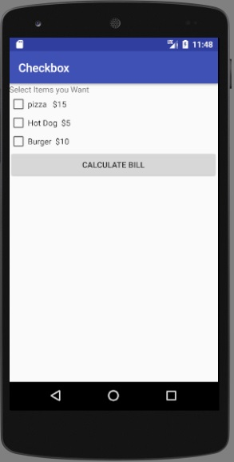 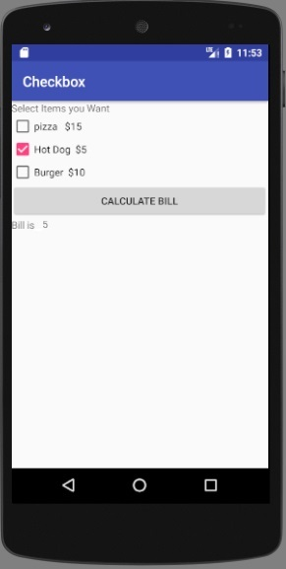

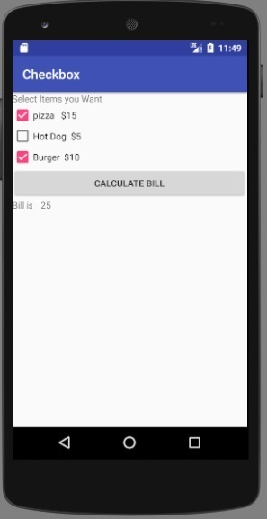

|  |  |
| --- | --- |
| Exp.No. 3.3(ii) | **CREATE APPLICATION BY USING CHOOSING OPTIONS(RADIO BUTTON)** |
| Dt. |

**AIM:** Creating the Application Choosing Options (Radiobutton)

**PROCEDURE**:

Step 1: Create a new project and name it RadioButtonExample

Select File -> New -> New Project and Fill the forms and click “Finish” button.

Step 2: Open res -> layout -> activity_main.[xml](https://abhiandroid.com/ui/xml) (or) main.[xml](https://abhiandroid.com/ui/xml) and add following code:

In this step we open an [xml](https://abhiandroid.com/ui/xml) file and add the code for displaying 5 RadioButton and one normal button.

6. Creating the Application by using RadioButton control.

<LinearLayout xmlns:android="http://schemas.android.com/apk/res/android"  
 android:orientation="vertical"  
 android:layout_width="match_parent"  
 android:layout_height="match_parent">  
 <TextView  
 android:layout_width="match_parent"  
 android:layout_height="wrap_content"  
 android:text="Select the type of hotel"/>  
 <RadioGroup  
 android:layout_width="match_parent"  
 android:layout_height="wrap_content"  
 android:orientation="vertical">  
 <RadioButton  
 android:id="@+id/radio_fivestar"  
 android:layout_width="wrap_content"  
 android:layout_height="wrap_content"  
 android:text="Five Star"/>   
 <RadioButton  
 android:id="@+id/radio_threestar"  
 android:layout_width="wrap_content"  
 android:layout_height="wrap_content"  
 android:text="Three Star"/>  
 </RadioGroup>  
 <TextView  
 android:layout_width="match_parent"  
 android:layout_height="wrap_content"  
 android:id="@+id/hoteltype"/>  
</LinearLayout>

**Step 3:** Open  src -> package -> **MainActivity.java**

In this step we open MainActivity and add the code to initiate the RadioButton and normal button.

packagecom.androidunleashed.radiobutttonapp;

import android.app.Activity;  
import android.os.Bundle;  
import android.widget.TextView;  
import android.widget.RadioButton;  
import android.view.View;  
import android.view.View.OnClickListener;  
public class RadioButtonAppActivty extends Activity{  
 @Override  
 protected void onCreate(Bundle savedInstanceState) {  
 super.onCreate(savedInstanceState);  
 setContentView(R.layout.activty_radio_button_app);  
 RadioButton radioFivestar=(RadioButton)findViewById(R.id.radio_fivestar);  
 RadioButton radioThreestar=(RadioButton)findViewById(R.id.radio_threestar);  
 radioFivestar.setOnClickListener(radioListener);  
 radioThreestar.setOnClickListener(radioListener);  
 }  
 private OnClickListener radioListener=new OnClickListener(){  
 public void onClick(View v){  
 TextView selectedHotel=(TextView)findViewById(R.id.hoteltype);  
 RadioButton rb=(RadioButton) v;  
 selectedHotel.setText("The hotel type selected is:" + rb.getText());  
 }  
 };  
}

**OUT PUT**

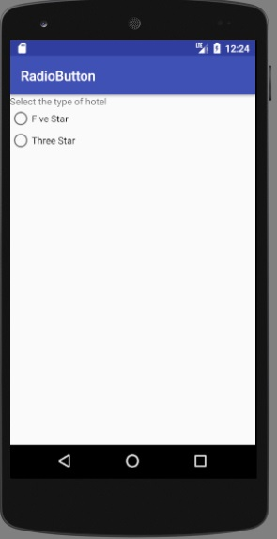 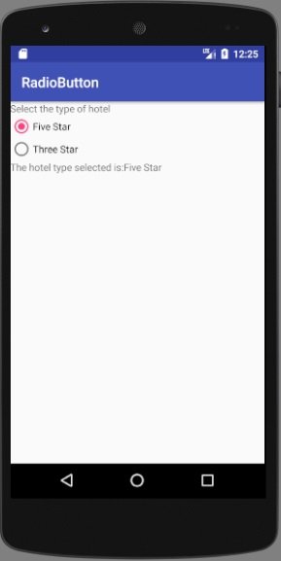

|  |  |
| --- | --- |
| Exp.No. 3.3(iii) | **CREATE APPLICATION BY USING CHOOSING OPTIONS (RADIO BUTTON GROUP)** |
| Dt. |

**AIM:** Creating the Application Choosing Options (Radiobuttongroup)

**PROCEDURE**:

**Step 1:** Create a new project in Android Studio and name it radiobuttongroupExample.

Select File -> New -> New Project and Fill the forms and click “Finish” button.

**Step 2:** Open res -> layout -> activity_main.[xml](https://abhiandroid.com/ui/xml) (or) main.[xml](https://abhiandroid.com/ui/xml) and add following code.

7. Creating the Application by using RadioGroup control.

<LinearLayout xmlns:android="http://schemas.android.com/apk/res/android"  
 android:orientation="vertical"  
 android:layout_width="match_parent"  
 android:layout_height="match_parent">  
 <TextView  
 android:layout_width="match_parent"  
 android:layout_height="wrap_content"  
 android:text="Select the type of hotel"/>  
 <RadioGroup  
 android:layout_width="match_parent"  
 android:layout_height="wrap_content"  
 android:orientation="vertical">  
 <RadioButton  
 android:id="@+id/radio_fivestar"  
 android:layout_width="wrap_content"  
 android:layout_height="wrap_content"  
 android:text="Five Star"/>  
 <RadioButton  
 android:id="@+id/radio_threestar"  
 android:layout_width="wrap_content"  
 android:layout_height="wrap_content"  
 android:text="Three Star"/>  
 </RadioGroup>  
 <TextView  
 android:layout_width="match_parent"  
 android:layout_height="wrap_content"  
 android:id="@+id/hoteltype"/>  
 <TextView  
 android:layout_width="match_parent"  
 android:layout_height="wrap_content"  
 android:text="Select the type of room"/>  
 <RadioGroup  
 android:id="@+id/group_room"  
 android:layout_width="match_parent"  
 android:layout_height="wrap_content"  
 android:orientation="vertical">  
 <RadioButton  
 android:id="@+id/radio_suite"  
 android:layout_width="wrap_content"  
 android:layout_height="wrap_content"  
 android:text="Grand Suite"/>  
 <RadioButton  
 android:id="@+id/radio_luxury"  
 android:layout_width="wrap_content"  
 android:layout_height="wrap_content"  
 android:text="Luxury Room"/>  
 <RadioButton  
 android:id="@+id/radio_ordinary"  
 android:layout_width="wrap_content"  
 android:layout_height="wrap_content"  
 android:text="ordinary Room"/>  
 </RadioGroup>  
 <TextView  
 android:layout_width="match_parent"  
 android:layout_height="wrap_content"  
 android:id="@+id/roomtype" />  
</LinearLayout>

**Step 3:** Now Open  app -> java-> package -> **MainActivity.java**

Package com.androidunleashed.radiobuttonapp;

import android.app.Activity;  
import android.os.Bundle;  
import android.widget.TextView;  
import android.widget.RadioButton;  
import android.view.View;  
import android.view.View.OnClickListener;  
public class RadioButtonAppActivity extends Activity{  
 String str1=" ";  
 String str2=" ";  
 @Override  
 protected void onCreate(Bundle savedInstanceState) {  
 super.onCreate(savedInstanceState);  
 setContentView(R.layout.activity_radio_button_app);  
 RadioButton radioFivestar = (RadioButton) findViewById(R.id.radio_fivestar);  
 RadioButton radioThreestar=(RadioButton) findViewById(R.id.radio_threestar);  
 RadioButton radioSuite = (RadioButton) findViewById(R.id.radio_suite);  
 RadioButton radioLuxury = (RadioButton) findViewById(R.id.radio_luxury);  
 RadioButton radioOrdinary = (RadioButton) findViewById(R.id.radio_ordinary);  
 radioFivestar.setOnClickListener(radioListener1);  
 radioThreestar.setOnClickListener(radioListener1);  
 radioSuite.setOnClickListener(radioListener2);  
 radioLuxury.setOnClickListener(radioListener2);  
 radioOrdinary.setOnClickListener(radioListener2);  
 }  
 private OnClickListener radioListener1 = new OnClickListener(){  
 public void onClick(View v) {  
 TextView selectedOptions = (TextView) findViewById(R.id.hoteltype);  
 RadioButton rb = (RadioButton) v;  
 str1 = "The hotel type selected is: " + rb.getText();  
 selectedOptions.setText(str1 + "\n" + str2);  
 }  
 };  
 private OnClickListener radioListener2 = new OnClickListener(){  
 public void onClick(View v){  
 TextView selectedOptions = (TextView) findViewById(R.id.hoteltype);  
 RadioButton rb = (RadioButton) v;  
 str2="Room type selected is: "+rb.getText();  
 selectedOptions.setText(str1+"\n"+str2);  
 }

};

}

**OUT PUT**

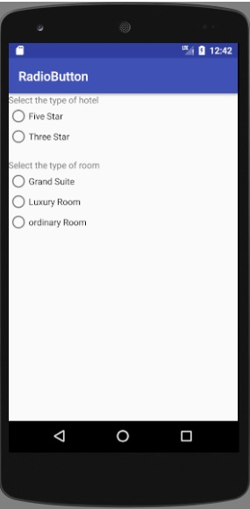 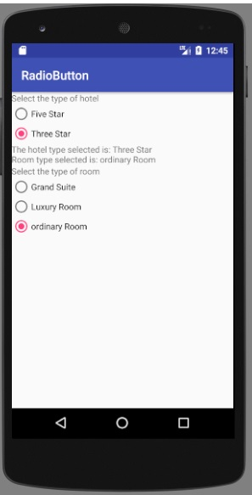 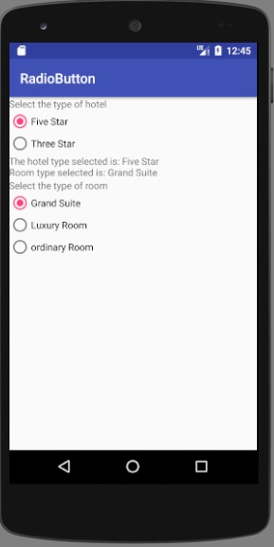

|  |  |
| --- | --- |
| Exp.No.  3.3(iv) | **CREATE APPLICATION BY USING CHOOSING OPTIONS (SPINNER)** |
| Dt. |

**AIM:** Creating the Application Choosing Options (Spinner)

**PROCEDURE**:

**Step 1:** Create a new project in Android Studio and name it SpinnerExample.

Select File -> New -> New Project and Fill the forms and click “Finish” button.

**Step 2:** Open res -> layout -> activity_main.[xml](https://abhiandroid.com/ui/xml) (or) main.[xml](https://abhiandroid.com/ui/xml) and add following code. Here we will create a Spinner inside [Relative Layout](https://abhiandroid.com/ui/relative-layout).

8. Creating the Application by using Spinner control.

**STRINGS.XML**

<resources>  
 <string name="app_name">SpinnerAppActivity</string>  
 <string name="choose_msg">Choose a fruit</string>  
</resources>

**ARRAYS.XML**

*<?*xml version="1.0" encoding="utf-8"*?>*<resources>  
 <string-array name="fruits">  
 <item>Apple</item>  
 <item>Mango</item>  
 <item>Banana</item>  
 <item>Orange</item>  
 <item>Grapes</item>  
 </string-array>  
</resources>

*<?*xml version="1.0" encoding="utf-8"*?>*<LinearLayout xmlns:android="http://schemas.android.com/apk/res/android"  
 xmlns:tools="http://schemas.android.com/tools"  
 android:layout_width="match_parent"  
 android:layout_height="match_parent"  
 android:orientation="vertical">  
 <Spinner  
 android:id="@+id/spinner"  
 android:layout_width="match_parent"  
 android:layout_height="wrap_content"  
 android:prompt="@string/choose_msg"  
 android:entries="@array/fruits">  
 </Spinner>  
 <TextView  
 android:id="@+id/selectedopt"  
 android:layout_width="match_parent"  
 android:layout_height="wrap_content" />  
</LinearLayout>

**Step 3:** Now open app-> java -> package -> MainActivity.java and add the following code. Here we will use Adapter to fill the data in Spinner.

package com.example.lenovo.spinnerappactivity;  
  
import android.support.v7.app.AppCompatActivity;  
import android.os.Bundle;  
import android.widget.TextView;  
import android.widget.Spinner;  
import android.widget.AdapterView;  
import android.view.View;  
import android.widget.AdapterView.OnItemSelectedListener;  
  
public class SpinnerAppActivity extends AppCompatActivity {  
  
 @Override  
 protected void onCreate(Bundle savedInstanceState) {  
 super.onCreate(savedInstanceState);  
 setContentView(R.layout.*activity_spinner_app*);  
 final TextView selectedOpt=(TextView)findViewById(R.id.*selectedopt*);  
 Spinner spin=(Spinner)findViewById(R.id.*spinner*);  
 final String[] fruitsArray = getResources().getStringArray(R.array.*fruits*);  
 spin.setOnItemSelectedListener(new OnItemSelectedListener() {  
 @Override  
 public void onItemSelected(AdapterView<?> parent, View view, int position, long id)

{  
 selectedOpt.setText("You have selected " + fruitsArray[position]);  
 }  
  
 @Override  
 public void onNothingSelected(AdapterView<?> parent) {  
 selectedOpt.setText(" ");  
 }  
 });  
  
 }  
}

**OUT PUT**

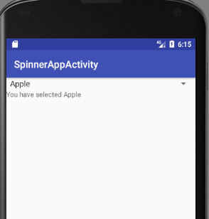 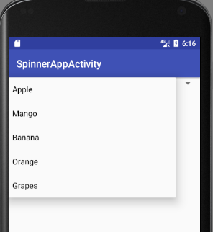 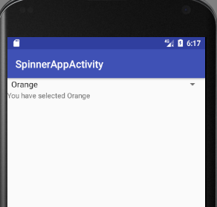

|  |  |
| --- | --- |
| Exp.No. 4 | **CREATE APPLICATION BY USING BUILDING BLOCKS FOR ANDROID APPLICATION DESIGN** |
| Dt. |

**4.1(i) AIM:** Design the Application by using Linear layout

**PROCEDURE**:

Step 1: Create a new project and name it Linear layout Example

Select File -> New -> New Project and Fill the forms and click “Finish” button.

In this step we create a new project in android studio by filling all the necessary details of the app like app name, package name, api versions etc.

Step 2: Now Open res -> layout -> activity_main.[xml](https://abhiandroid.com/ui/xml) (or) main.[xml](https://abhiandroid.com/ui/xml) and add the following code:

9. Design the Application by using Linear Layout.

*<?*xml version="1.0" encoding="utf-8"*?>*<LinearLayout xmlns:android="http://schemas.android.com/apk/res/android"  
 android:layout_width="match_parent"  
 android:layout_height="match_parent"  
 android:orientation="vertical">  
 <Button  
 android:id="@+id/Apple"  
 android:text="Apple"  
 android:layout_width="match_parent"  
 android:layout_height="wrap_content"  
 android:gravity="center_vertical"  
 android:layout_weight="1.0" />  
 <Button  
 android:id="@+id/Mango"  
 android:text="Mango"  
 android:layout_width="match_parent"  
 android:layout_height="wrap_content"  
 android:gravity="center"  
 android:layout_gravity="center"  
 android:layout_weight="1.0"/>  
 <Button  
 android:id="@+id/Banana"  
 android:text="Banana"  
 android:layout_width="match_parent"  
 android:layout_height="wrap_content"  
 android:gravity="center_vertical|right"  
 android:layout_weight="1.0"  
 android:layout_gravity="right"/>  
</LinearLayout>

**Step 3:** Now Open  app -> java-> package -> **MainActivity.java**

In this step we add the code to initiate the linear layout fruit names

**LinearLayoutApp.java**

package com.example.lenovo.LinearLayoutApp;  
import android.support.v7.app.AppCompatActivity;  
import android.os.Bundle;  
  
public class MainActivity extends AppCompatActivity {  
 @Override  
 protected void onCreate(Bundle savedInstanceState) {  
 super.onCreate(savedInstanceState);  
 setContentView(R.layout.layout*_app_linear*);  
 }  
}

**OUT PUT**

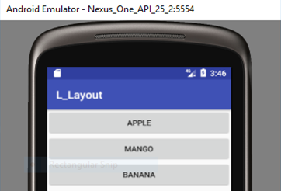

|  |  |
| --- | --- |
| Exp.No.4.1(ii) | **CREATE APPLICATION BY USING RELATIVE LAYOUT** |
| Dt. |

**AIM:** Design the Application by using (Relative Layout)

**PROCEDURE**:

Step 1: Create a new project and name it RelativelayoutExample

In this step we create a new project in android studio by filling all the necessary details of the app like app name, package name, api versions etc.

Select File -> New -> New Project and Fill the forms and click “Finish” button.

Step 2: Now Open res -> layout -> activity_main.[xml](https://abhiandroid.com/ui/xml) (or) main.[xml](https://abhiandroid.com/ui/xml) and add the following code:

10. Design the Application by using Relative Layout.

*<?*xml version="1.0" encoding="utf-8"*?>*<RelativeLayout xmlns:android="http://schemas.android.com/apk/res/android"  
 android:layout_width="match_parent"  
 android:layout_height="match_parent"  
 android:orientation="horizontal">  
 <TextView  
 android:id="@+id/sign_msg"  
 android:text="Sign In"  
 android:layout_width="wrap_content"  
 android:layout_height="wrap_content"  
 android:typeface="serif"  
 android:textSize="25dip"  
 android:textStyle="bold"  
 android:padding="10dip"  
 android:layout_centerHorizontal="true" />  
 <TextView  
 android:id="@+id/user_msg"  
 android:text="User ID"  
 android:layout_width="wrap_content"  
 android:layout_height="wrap_content"  
 android:layout_margin="10dip"  
 android:layout_below="@id/sign_msg"/>  
 <EditText  
 android:id="@+id/user_ID"  
 android:layout_width="250dip"  
 android:layout_height="wrap_content"  
 android:layout_below="@id/sign_msg"  
 android:layout_toRightOf="@id/user_msg"  
 android:maxLines="1"/>  
 <TextView  
 android:id="@+id/psw_msg"  
 android:text="Password"  
 android:layout_width="wrap_content"  
 android:layout_height="wrap_content"  
 android:layout_below="@id/user_msg"  
 android:layout_margin="10dip"  
 android:paddingTop="10dip"/>  
 <EditText  
 android:id="@+id/psw"  
 android:layout_width="250dip"  
 android:layout_height="wrap_content"  
 android:maxLines="1"  
 android:layout_below="@id/user_ID"  
 android:layout_toRightOf="@id/psw_msg"  
 android:inputType="textPassword"/>

<Button  
 android:id="@+id/login_button"  
 android:text="Sign In"  
 android:layout_width="wrap_content"  
 android:layout_height="wrap_content"  
 android:layout_centerHorizontal="true"  
 android:layout_marginTop="10dip"  
 android:layout_below="@+id/psw_msg/>  
<TextView  
 android:layout_width="match_parent"  
 android:layout_height="wrap_content"  
 android:id="@+id/resp"  
 android:layout_below="@id/login_button"/>  
</RelativeLayout>

**Step 3:** Now Open  app -> java-> package -> **MainActivity.java**

In this step we add the code to initiate Relative layout using a textview

import android.support.v7.app.AppCompatActivity;  
import android.os.Bundle;  
import android.view.View.OnClickListener;  
import android.widget.EditText;  
import android.widget.TextView;  
import android.view.View;  
import android.widget.Button;  
public class MainActivity extends AppCompatActivity implements OnClickListener {  
 @Override  
 protected void onCreate(Bundle savedInstanceState) {  
 super.onCreate(savedInstanceState);  
 setContentView(R.layout.*activity_main*);  
 Button b=(Button)this.findViewById(R.id.*login_button*);  
 b.setOnClickListener(this);  
 }

public void onClick(View v)  
 {  
 EditText uid= (EditText)findViewById(R.id.*user_ID*);  
 EditText psw= (EditText)findViewById(R.id.*psw*);  
 TextView resp= (TextView)this.findViewById(R.id.*resp*);  
 String usr=uid.getText().toString();  
 String pswd = psw.getText().toString();  
 if (usr.trim().length()==0 || pswd.trim().length()==0) {  
 String str = "The User ID or Password is left blank \n Please Try Again.";  
 resp.setText(str);  
 }  
 else  
 {  
 if(usr.equals("venki")&& pswd.equals("venki"))  
 resp.setText("Welcome "+usr+" ! ");  
 else resp.setText("The User ID or Password is Incorrect\nPlease Try Again.");  
 }  
 }  
}

**OUT PUT**

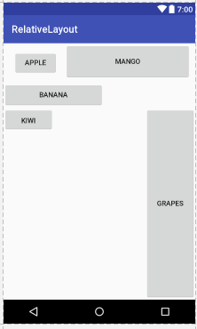

|  |  |
| --- | --- |
| Exp.No. 4.1(iii) | **CREATE APPLICATION BY USING ABSOLUTE LAYOUT** |
| Dt. |

**AIM:** Design the Application by using Absolute Layout

**PROCEDURE**:

Step 1: Create a new project and name it AbsolutelayoutExample

In this step we create a new project in android studio by filling all the necessary details of the app like app name, package name, api versions etc.

Select File -> New -> New Project and Fill the forms and click “Finish” button.

Step 2: Now Open res -> layout -> activity_main.[xml](https://abhiandroid.com/ui/xml) (or) main.[xml](https://abhiandroid.com/ui/xml) and add the following code:

11. Design the Application by using Absolute Layout.

*<?*xml version="1.0" encoding="utf-8"*?>*<AbsoluteLayout xmlns:android="http://schemas.android.com/apk/res/android"  
 android:layout_width="match_parent"  
 android:layout_height="match_parent"  
 android:orientation="vertical" >  
 <TextView  
 android:layout_width="wrap_content"  
 android:layout_height="wrap_content"  
 android:layout_x="90dip"  
 android:layout_y="2dip"  
 android:text="New Product Form"  
 android:textSize="20sp"  
 android:textStyle="bold" />  
 <TextView  
 android:layout_width="wrap_content"  
 android:layout_height="wrap_content"  
 android:text="Product Code"  
 android:layout_x="5dip"  
 android:layout_y="40dip" />  
 <EditText  
 android:id="@+id/p_code"  
 android:layout_width="wrap_content"  
 android:layout_height="wrap_content"  
 android:layout_x="110dip"  
 android:layout_y="30dip"  
 android:minWidth="100dip" />  
 <TextView  
 android:layout_width="wrap_content"  
 android:layout_height="wrap_content"  
 android:text="Product Name"  
 android:layout_x="5dip"  
 android:layout_y="90dip" />  
 <EditText  
 android:id="@+id/p_name"  
 android:layout_width="200dip"  
 android:layout_height="wrap_content"  
 android:layout_x="110dip"  
 android:layout_y="80dip"  
 android:minWidth="200dip"  
 android:scrollHorizontally="true" />  
 <TextView  
 android:layout_width="wrap_content"  
 android:layout_height="wrap_content"  
 android:text="Product Price"  
 android:layout_x="5dip"  
 android:layout_y="140dip" />  
 <EditText  
 android:id="@+id/p_price"  
 android:layout_width="wrap_content"  
 android:layout_height="wrap_content"  
 android:layout_x="110dip"  
 android:layout_y="130dip"  
 android:minWidth="100dip" />  
 <Button  
 android:layout_width="wrap_content"  
 android:layout_height="wrap_content"  
 android:id="@+id/click_btn"  
 android:text="Add New Product"  
 android:layout_x="80dip"  
 android:layout_y="190dip"/>  
</AbsoluteLayout>

**Step 3:** Now Open  app -> java-> package -> **MainActivity.java**

In this step we add the code to initiate Absolute layout using a Textview

**AbsoluteLayoutApp.java**

package com.example.lenovo.AbsoluteLayoutApp;  
import android.support.v7.app.AppCompatActivity;  
import android.os.Bundle;  
  
public class MainActivity extends AppCompatActivity {  
 @Override  
 protected void onCreate(Bundle savedInstanceState) {  
 super.onCreate(savedInstanceState);  
 setContentView(R.layout.layout*_app_absolute*);  
 }  
}

**OUT PUT**

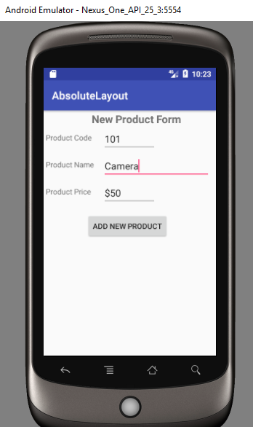

|  |  |
| --- | --- |
| Exp.No. 4.2 | **CREATE APPLICATION BY USING AUDIO & VIDEO CLIPS** |
| Dt. |

**AIM:** Create the Application to play the Audio clip

**PROCEDURE**:

**Step 1: Create a new project in Android Studio and name it Audioclip**

Select File -> New -> New Project and Fill the forms and click “Finish” button.

**Step 2: Open res -> layout -> xml (or) main.xml and add following code :**

**In this step we open an xml file and add the code to display a toggle button in our activity.**

12. Create the Application to play the Audio.

*<?*xml version="1.0" encoding="utf-8"*?>*<LinearLayout xmlns:android="http://schemas.android.com/apk/res/android"  
 android:orientation="vertical"  
 android:layout_width= "match_parent"  
 android:layout_height="match_parent">  
 <TextView  
 android:layout_width="match_parent"  
 android:layout_height="wrap_content"  
 android:id="@+id/response"  
 android:gravity="center" />  
 <ToggleButton  
 android:id="@+id/playstop_btn"  
 android:layout_width= "wrap_content"  
 android:layout_height="wrap_content"  
 android:layout_gravity="center"  
 android:textOn= " "  
 android:textOff=""  
 android:background="@drawable/play" />  
</LinearLayout>

**Step 3: Open src -> package -> MainActivity.java**

**In this step we open MainActivity and add the code to initiate the video view and create an object of MediaController to control the video playback.**

**Add raw directory under resource and paste audio under raw directory**

package com.example.lenovo.playaudio;  
  
import android.support.v7.app.AppCompatActivity;  
import android.os.Bundle;  
import android.widget.ToggleButton;  
import android.view.View;  
import android.widget.TextView;  
import android.media.MediaPlayer;  
import android.view.View.OnClickListener;  
  
public class PlayAudioApp extends AppCompatActivity {  
  
 @Override  
 protected void onCreate(Bundle savedInstanceState) {  
 super.onCreate(savedInstanceState);  
 setContentView(R.layout.*activity_play_audio_app*);  
 final TextView response = (TextView)this.findViewById(R.id.*response*);  
 response.setText("Select Play button to play audio");  
 final MediaPlayer mp = MediaPlayer.*create*(PlayAudioApp.this,R.raw.*song1*);  
 final ToggleButton playStopButton = (ToggleButton)findViewById(R.id.*playstop_btn*);  
 playStopButton.setOnClickListener(new OnClickListener() {  
 public void onClick(View v) {  
 if (playStopButton. isChecked()) {  
 response.setText("Select Stop button to stop audio");

playStopButton.setBackgroundDrawable(getResources().getDrawable(R.drawable.*stop*));  
 mp.start();  
 }  
 else {  
 response.setText("Select Play button to play audio");  
 playStopButton.setBackgroundDrawable(getResources().getDrawable(R. drawable.*play*));  
 mp.pause ();  
 }  
 }  
 });  
 }  
}

**OUT PUT**

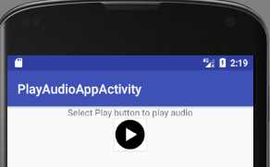 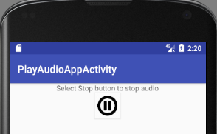

**AIM:** Create the Application to play the video clip

**PROCEDURE**:

**Step 1: Create a new project in Android Studio and name it VideoViewExample**

Select File -> New -> New Project and Fill the forms and click “Finish” button.

**Step 2: Open res -> layout -> xml (or) main.xml and add following code :**

**In this step we open an xml file and add the code to display a VideoView in our activity.**

13. Create the Application to play the Video clips.

*<?*xml version="1.0" encoding="utf-8"*?>*<LinearLayout xmlns:android="http://schemas.android.com/apk/res/android"  
 xmlns:tools="http://schemas .android.com/tools"  
 android:orientation="vertical"  
 android:layout_width= "match_parent"  
 android:layout_height="match_parent" >  
 <VideoView android:id="@+id/video"  
 android:layout_width="match_parent"  
 android:layout_height="420dip" />  
 <Button android:id= "@+id/playvideo"  
 android:text="Play Video"  
 android:layout_height="wrap_content"  
 android:layout_width="match_parent" />  
</LinearLayout>

**Step 3: Open src -> package -> MainActivity.java**

**In this step we open MainActivity and add the code to initiate the video view and create an object of MediaController to control the video playback.**

**Add raw directory under resource and paste video under raw directory**

**In this class we also set the uri for the video and perform set on error and completion listener events and display Toast message when video is completed or an error is occur while playing thee video.**

**Also make sure to create a new directory in res folder and name it raw. Save a video name vid in raw folder.**

package com.example.lenovo.playingvideo;  
  
import android.support.v7.app.AppCompatActivity;  
import android.os.Bundle;  
import android.view.View;  
import android.widget.Button;  
import android.widget.MediaController;  
import android.view.View.OnClickListener;  
import android.widget.VideoView;  
  
public class PlayingVideo extends AppCompatActivity {  
  
 @Override  
 protected void onCreate(Bundle savedInstanceState) {  
 super.onCreate(savedInstanceState);  
 setContentView(R.layout.*activity_playing_video*);  
 Button playVideoButton = (Button) findViewById(R.id.*playvideo*);  
 playVideoButton.setOnClickListener(new OnClickListener() {  
 public void onClick(View view) {  
 VideoView videoView = (VideoView) findViewById(R.id.*video*);  
 videoView.setMediaController(new  
 MediaController(PlayingVideo.this));  
 videoView.setVideoPath(

"android.resource://com.example.lenovo.playingvideo/"+R.raw.*vid*);  
 videoView.requestFocus();  
 videoView.start();  
 }  
 });  
 }  
}

**OUT PUT**

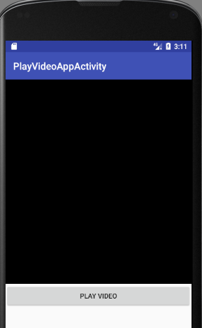 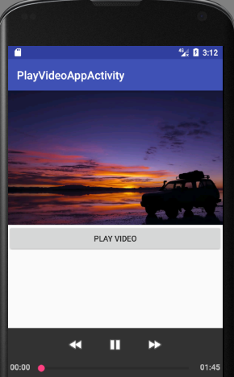

|  |  |
| --- | --- |
| Exp.No. 5 | **CREATE APPLICATION BY USING BUILDING MENUS AND STORING DATA** |
| Dt. |

**5.1 AIM:** Design the Application for Menus and Action Bar

**PROCEDURE**:

Step 1: Create a new project and name it MenuExample

In this step we create a new project in android studio by filling all the necessary details of the app like app name, package name, api versions etc.

Select File -> New -> New Project and Fill the forms and click “Finish” button.

Step 2: Now Open res -> layout -> activity_main.[xml](https://abhiandroid.com/ui/xml) (or) main.[xml](https://abhiandroid.com/ui/xml) and add the following code:

14. Design the Application for Menus and Action Bar.

*<?*xml version="1.0" encoding="utf-8"*?>*<android.support.constraint.ConstraintLayout

xmlns:android="http://schemas.android.com/apk/res/android"  
 xmlns:app="http://schemas.android.com/apk/res-auto"  
 xmlns:tools="http://schemas.android.com/tools"  
 android:layout_width="match_parent"  
 android:layout_height="match_parent"  
 tools:context="com.example.lenovo.menuactiobar.MainActivity">  
 <TextView  
 android:layout_width="wrap_content"  
 android:layout_height="wrap_content"  
 android:text="Hello World!"  
 app:layout_constraintBottom_toBottomOf="parent"  
 app:layout_constraintLeft_toLeftOf="parent"  
 app:layout_constraintRight_toRightOf="parent"  
 app:layout_constraintTop_toTopOf="parent" />  
</android.support.constraint.ConstraintLayout>

**Step 3:** Now Open  app -> java-> package -> **MainActivity.java**

In this step we add the code to display menu on action bar

package com.example.lenovo.menuactionbar;  
import android.support.v7.app.AppCompatActivity;  
import android.os.Bundle;  
import android.view.Menu;  
import android.view.MenuItem;  
import android.widget.Toast;  
public class MainActivity extends AppCompatActivity {  
 @Override  
 protected void onCreate(Bundle savedInstanceState) {  
 super.onCreate(savedInstanceState);  
 setContentView(R.layout.*activity_main*);  
 }  
 @Override  
 public boolean onCreateOptionsMenu(Menu menu) {  
 getMenuInflater().inflate(R.menu.*main_menu*,menu);  
 return true;  
 }  
 @Override  
 public boolean onOptionsItemSelected(MenuItem item) {  
 switch(item.getItemId()){  
 case R.id.*settings*:  
 Toast.*makeText*(this,"Settings Selected" , Toast.*LENGTH_LONG*).show();  
 return true;  
 case R.id.*share*:  
 Toast.*makeText*(this,"Share Selected" , Toast.*LENGTH_LONG*).show();  
 return true;  
 case R.id.*refresh*:  
 Toast.*makeText*(this,"Refresh Selected" , Toast.*LENGTH_LONG*).show();  
 return true;

case R.id.*search*:  
 Toast.*makeText*(this,"Search Selected" , Toast.*LENGTH_LONG*).show();  
 return true;  
 case R.id.*help*:  
 Toast.*makeText*(this,"Help Selected" , Toast.*LENGTH_LONG*).show();  
 return true;  
 default:  
 return super.onOptionsItemSelected(item);  
 }  
  
 }  
}

**Step 4:** Open res ->values -> **strings.**[xml](https://abhiandroid.com/ui/xml)

In this step we show string file which is used to store string data of an app.

**strings.**[xml](https://abhiandroid.com/ui/xml)

<resources>  
 <string name="app_name">Menuactiobar</string>  
 <string name="settings">Settings</string>  
 <string name="share">Share</string>  
 <string name="search">Search</string>  
 <string name="refresh">Refresh</string>  
 <string name="help">Help</string>  
</resources>

**Step 5:**

Add menu resource directory then add menu resource file

Open res ->menu-> Main_menu.xml

In this step we show string file which is used to store string data of an app.

 Main_menu.xml

<menu xmlns:android="http://schemas.android.com/apk/res/android"  
 xmlns:app="http://schemas.android.com/apk/res-auto">  
 <item  
 android:id="@+id/settings"  
 app:showAsAction="never"  
 android:title="@string/settings" />  
 <item  
 android:id="@+id/refresh"  
 app:showAsAction="never"  
 android:title="@string/refresh" />  
 <item  
 android:id="@+id/share"  
 app:showAsAction="never"  
 android:title="@string/share" />  
 <item  
 android:id="@+id/search"  
 app:showAsAction="never"  
 android:title="@string/search" />  
 <item  
 android:id="@+id/help"  
 app:showAsAction="never"  
 android:title="@string/help" />  
</menu>

|  |  |
| --- | --- |
| Exp.No. 5.2 | **CREATE APPLICATION BY USING DROP-DOWN LIST ACTION BAR** |
| Dt. |

**AIM:** Design the application to display the Drop-Down List Action Bar

**PROCEDURE**:

Step 1: Create a new project and name it Dropdownlistactionbarexample

In this step we create a new project in android studio by filling all the necessary details of the app like app name, package name, api versions etc.

Select File -> New -> New Project and Fill the forms and click “Finish” button.

Step 2: Now Open res -> layout -> activity_main.[xml](https://abhiandroid.com/ui/xml) (or) main.[xml](https://abhiandroid.com/ui/xml) and add the following code:

15. Design the application to display the Drop-Down List Action Bar.

*<?*xml version="1.0" encoding="utf-8"*?>*<RelativeLayout xmlns:android="http://schemas.android.com/apk/res/android"  
 xmlns:app="http://schemas.android.com/apk/res-auto"  
 android:layout_width="match_parent"  
 android:layout_height="match_parent">  
  
<android.support.v7.widget.Toolbar  
android:id="@+id/toolbar"  
android:layout_width="match_parent"  
android:layout_height="wrap_content"  
android:layout_alignParentLeft="true"  
android:layout_alignParentStart="true"  
android:layout_alignParentTop="true"  
android:background="@color/colorPrimary"  
app:theme="@style/ThemeOverlay.AppCompat.Dark.ActionBar">  
  
<Spinner  
 android:id="@+id/spinner"  
 android:layout_width="wrap_content"  
 android:layout_height="wrap_content"  
 android:layout_alignLeft="@+id/toolbar"  
 android:layout_alignStart="@+id/toolbar"  
 android:layout_below="@+id/toolbar"  
 android:layout_gravity="end"  
 android:layout_marginEnd="10dp"  
 android:layout_marginRight="10dp"  
 app:popupTheme="@style/ThemeOverlay.AppCompat.Light" />  
</android.support.v7.widget.Toolbar>  
</RelativeLayout>

**Step 3:** Open res ->values -> Cu**st0m spinner item.**[xml](https://abhiandroid.com/ui/xml)

Custom_spinner_item.xml

*<?*xml version="1.0" encoding="utf-8"*?>*<TextView android:textColor="@android:color/white"  
 android:layout_height="match_parent"  
 android:layout_width="match_parent"  
 xmlns:android="http://schemas.android.com/apk/res/android">  
</TextView>

**Step 4:** Open res ->values -> **strings.**[xml](https://abhiandroid.com/ui/xml)

In this step we show string file which is used to store string data of an app.

Strings.xml

*<?*xml version="1.0"*?>*<resources>  
 <string name="app_name">DropDown ActionBar</string>  
 <string-array name="names">  
 <item>IV-CSE-A</item>  
 <item>IV-CSE-B</item>  
 <item>IV-CSE-C</item>  
 <item>IV-CSE-D</item>  
 </string-array>  
</resources>

Styles.xml

<resources>  
 *<!-- Base application theme. -->* <style name="AppTheme" parent="Theme.AppCompat.Light.NoActionBar">  
 *<!-- Customize your theme here. -->* <item name="colorPrimary">@color/colorPrimary</item>  
 <item name="colorPrimaryDark">@color/colorPrimaryDark</item>  
 <item name="colorAccent">@color/colorAccent</item>  
 </style>  
</resources>

**Step 5:** Now Open  app -> java-> package -> **MainActivity.java**

In this step we add the code to initiate the check boxes we created. And then we perform click event on button and display the text for selected check boxes using a TextView

**package** com.example.lenovo.dropdownlist;  
  
**import** android.support.v7.app.AppCompatActivity;  
**import** android.os.Bundle;  
**import** android.support.v7.widget.Toolbar;  
**import** android.widget.Toast;  
**import** android.view.View;  
**import** android.widget.AdapterView;  
**import** android.widget.ArrayAdapter;  
**import** android.widget.Spinner;  
  
**public class** ListActionBarAppActivity **extends** AppCompatActivity {  
 Toolbar **myToolbar**;  
 Spinner **mySpinner**;  
 @Override  
 **protected void** onCreate(Bundle savedInstanceState) {  
 **super**.onCreate(savedInstanceState);  
 setContentView(R.layout.***activity_list_action_bar_app***);  
 **myToolbar** = (Toolbar) findViewById(R.id.***toolbar***);  
 **mySpinner** = (Spinner) findViewById(R.id.***spinner***);  
 **myToolbar**.setTitle(getResources().getString(R.string.***app_name***));  
 ArrayAdapter<String>myAdapter = **new** ArrayAdapter<String>(ListActionBarAppActivity.**this**,  
 R.layout.***custom_spinner_item***,getResources().getStringArray(R.array.***names***));  
 myAdapter.setDropDownViewResource(android.R.layout.***simple_spinner_dropdown_item***);  
 **mySpinner**.setAdapter(myAdapter);  
 **mySpinner**.setOnItemSelectedListener(**new** AdapterView.OnItemSelectedListener() {  
 @Override  
 **public void** onItemSelected(AdapterView<?>adapterView, View view, **int** i, **long** l) {  
 Toast.*makeText*(ListActionBarAppActivity.**this**,  
 **mySpinner**.getSelectedItem().toString(),  
 Toast.***LENGTH_SHORT***).show();  
 }  
 @Override  
 **public void** onNothingSelected(AdapterView<?>adapterView) {  
 }  
 });  
 }  
}

